During this critical time, many individuals are seeking opportunities to help their fellow community members – ways in which they can make an impact and inspire hope. Although there are new volunteer opportunities being announced every day, like those you can find at www.feedtoledokids.og, we recognize that some populations and individuals aren’t comfortable or able to help in such public-facing ways.
Here are some helpful suggestions to make an impact, without direct contact:
- Go to www.211nwo.org, click on our “community resource database,” and search for shelters or food pantries near you (simply type in your zip code). Reach out and see what products or types of kits they might need. In addition to food, many locations also need hygiene items and paper products, or hygiene and cleaning kits that you could assemble at home.
- At https://promedicahealthconnect.org/news-and-community/help-the-shortage-volunteers-needed-to-sew-fabric-face-masks/ you can find details on how to make masks that our front line medical personnel are in desperate need of. You can also go to https://www.joann.com/make-to-give-response/ for how-to instructions and availability of free supplies.
- Many religious organizations throughout the community are offering different types of help to Senior Citizens, who are currently housebound (i.e. one church is doing grocery pick-up and delivery for seniors, and leaving them on their porch). Contact your community religious organization(s) to see if they are doing something similar.
- Consider volunteering to be a trained crisis counselor, with web-based training, to support people virtually, as there is an increased need due to the stress and anxiety many individuals are experiencing at this time. https://mha.ohio.gov/Families-Children-and-Adults/Get-Help/Crisis-Text-Line
- Contact an area senior facility or nursing home to see if they have any residents that could use a virtual visit, (like a phone call or a video message).
- Use your skills and talents to offer virtual tutoring for students of family and friends, (many parents who are now “homeschooling” would appreciate the break and expertise).
- Share volunteer opportunities or community needs on social media or to private groups that you are part of – nonprofits rely on word of mouth communication to get volunteers and needed items. There is strength in your words.
- Help our community learn that, by contacting 2-1-1, they can get 24/7 referral access to food for children while school is out, info on food pantries, financial assistance information and access to thousands of other health and human services. United Way 2-1-1 is free and can be reached by dialing 2-1-1, texting your zip code to 898-211, or using the chat feature at www.211nwo.org.
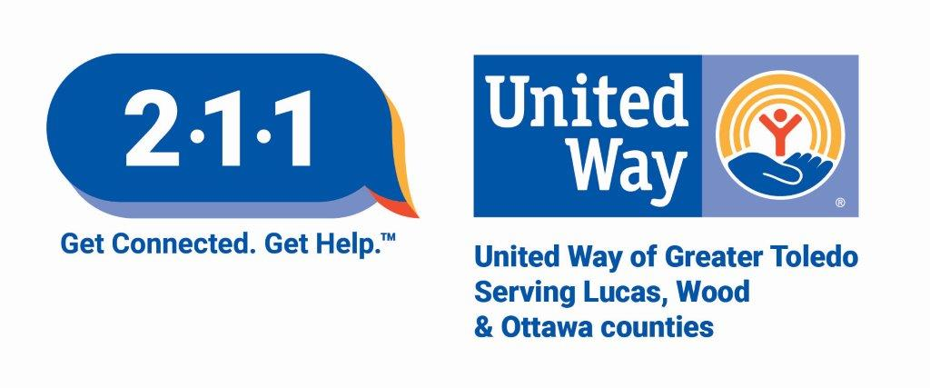
Volunteerism that helps those in need is an essential service in our community, particularly during this pandemic. Find a way that works for you. The return on doing good provides optimism, inspiration and so much more. Your service is needed now more than ever!

